Answer 2
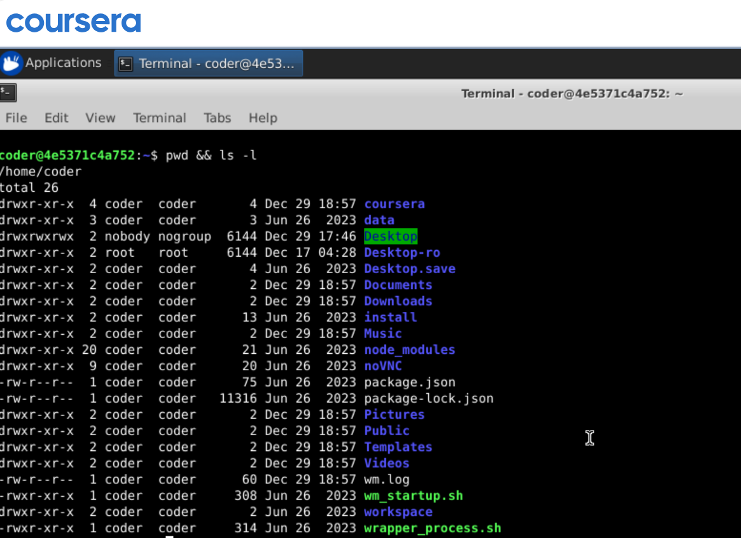
Explanation: Using pwd command which gives print working directory and after that using && symbol which mean run the second command only if first command execute successfully. That how ls -l show us the directories and files inside current directory. Another way to do this running both the command one by one separately.

